**Design and Implement an ATM on Arduino**

In this project, the C++ programming language is used to program the Arduino board.

STEP 1. Install the Arduino IDE to upload the code in the Arduino board.

STEP 2. Select the Arduino board type and connect the serial port.

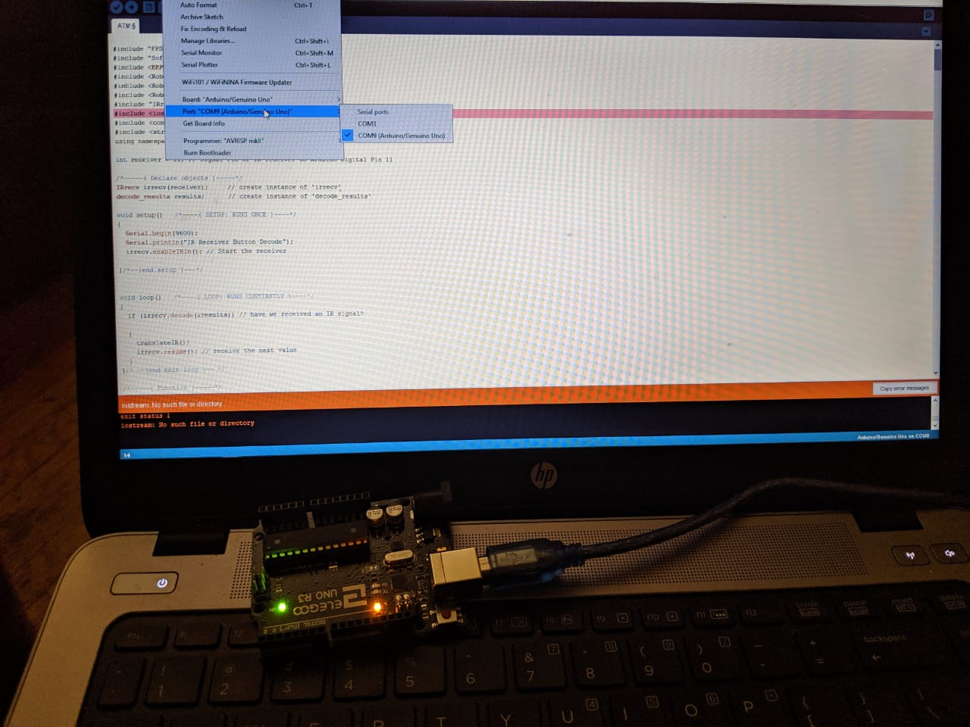

STEP 3. Make the circuit.

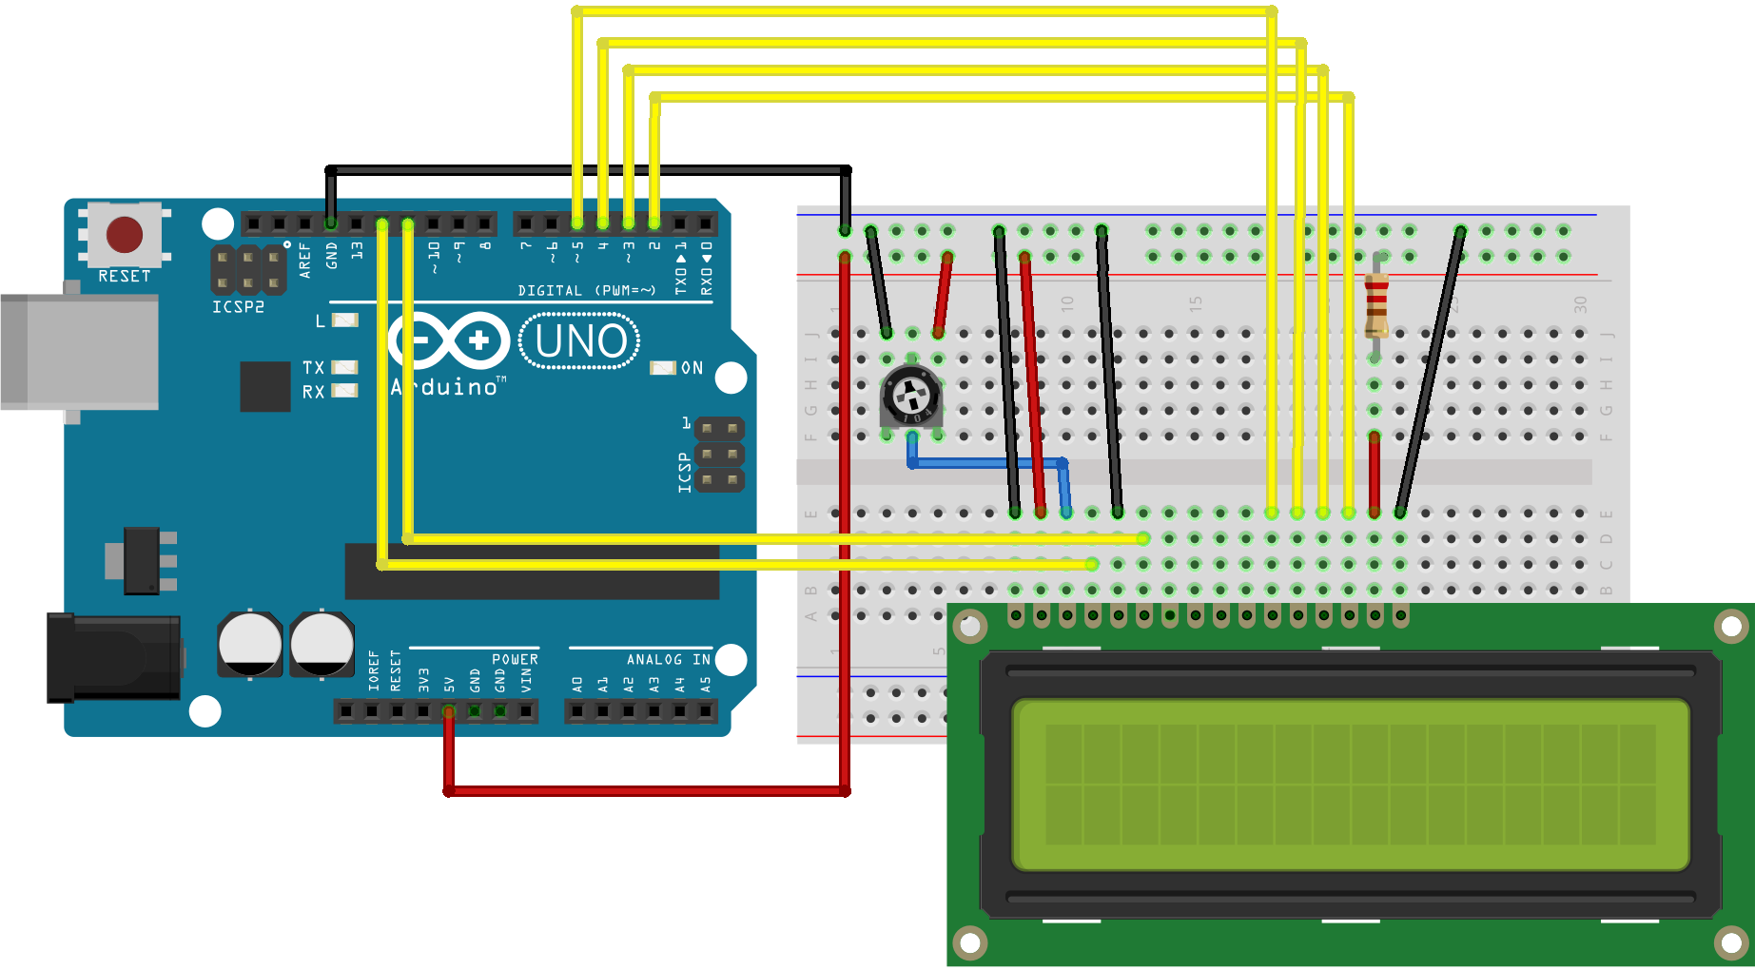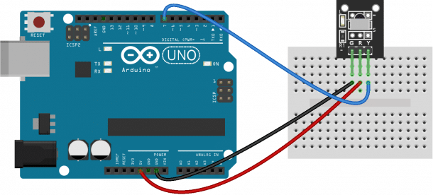

STEP 4. Write the code the upload it into the Arduino.

#include "FPS_GT511C3.h"

#include "SoftwareSerial.h"

#include <EEPROM.h>

#include <RobotIRremote.h>

#include <RobotIRremoteInt.h>

#include <RobotIRremoteTools.h>

#include "IRremote.h"

#include <iostream>

#include <conio.h>

#include <string.h>

using namespace std;

int receiver = 11; // Signal Pin of IR receiver to Arduino Digital Pin 11

/*-----( Declare objects )-----*/

IRrecv irrecv(receiver); // create instance of 'irrecv'

decode_results results; // create instance of 'decode_results'

void setup() /*----( SETUP: RUNS ONCE )----*/

{

Serial.begin(9600);

Serial.println("IR Receiver Button Decode");

irrecv.enableIRIn(); // Start the receiver

}/*--(end setup )---*/

void loop() /*----( LOOP: RUNS CONSTANTLY )----*/

{

if (irrecv.decode(&results)) // have we received an IR signal?

{

translateIR();

irrecv.resume(); // receive the next value

}

}/* --(end main loop )-- */

/*-----( Function )-----*/

void translateIR() // takes action based on IR code received

// describing Remote IR codes

{

switch(results.value)

{

case 0xFF22DD: Serial.println(" LEFT"); break;

case 0xFF02FD: Serial.println(" -OK-"); break;

case 0xFFC23D: Serial.println(" RIGHT"); break;

case 0xFF6897: Serial.println(" 1"); break;

case 0xFF9867: Serial.println(" 2"); break;

case 0xFFB04F: Serial.println(" 3"); break;

case 0xFF30CF: Serial.println(" 4"); break;

case 0xFF18E7: Serial.println(" 5"); break;

case 0xFF7A85: Serial.println(" 6"); break;

case 0xFF10EF: Serial.println(" 7"); break;

case 0xFF38C7: Serial.println(" 8"); break;

case 0xFF5AA5: Serial.println(" 9"); break;

case 0xFF4AB5: Serial.println(" 0"); break;

default:

Serial.println(" other button ");

}// End Case

delay(500); // Do not get immediate repeat

}

// include the library code:

#include <LiquidCrystal.h>

// initialize the library by associating any needed LCD interface pin

// with the arduino pin number it is connected to

const int rs = 12, en = 11, d4 = 5, d5 = 4, d6 = 3, d7 = 2;

LiquidCrystal lcd(rs, en, d4, d5, d6, d7);

void setup() {

// set up the LCD's number of columns and rows:

lcd.begin(16, 2);

// Print a message to the LCD.

//lcd.print("HELLO");

}

void loop() {

// set the cursor to column 0, line 1

// (note: line 1 is the second row, since counting begins with 0):

lcd.setCursor(0, 1);

}

unsigned int difference ( unsigned int &start_time, unsigned int &end_time )

{

end_time = clock();

return ( ( end_time - start_time ) /1000 );

}

int main ()

{

string account = "";

string password = "";

bool loginSuccess = false;

unsigned int start_time = clock();

unsigned int end_time;

s2:

cout << "\nHELLO\n"; //system start with the world "HELLO"

do{

cout << "Acc.No: ";

while ( difference ( start_time, end_time) < 60 )

{

cout<< difference ( start_time, end_time) << endl; //wait for 60 seconds after that it will exit the main() and start again .

cin >> account;

}

s3:

cout << "PassCO: ";

while ( difference ( start_time, end_time) < 60 )

{

cout<< difference ( start_time, end_time) << endl; //wait for 60 seconds after that it will exit the main() and start again .

cin >> password;

}

//////////////////////////////

if(account == "100000" && password == "1000")

{

cout << "\n Welcome Mr./Ms. A";

loginSuccess = true;

cout << "\n\t* 1. Check Balance *";

cout << "\n\t* 2. Withdraw *";

cout << "\n\t* 3. Deposit *";

cout << "\n\t* 4. Exit *";

int balance=1323;

int withdraw;

int deposit;

s:

cout << "\nEnter Number: ";

cin >> choice;

if (choice==1)

{

cout <<"\n/mr./Ms. A: \n" << balance; //display balance along with user name

goto s;

}

else if (choice==2)

{

cout << "\amt: ";

cin >> withdraw;

if (withdraw>balance && withdraw < 0)

{

cout << "\nERROR\n";

delay(2000); // 2 sec. delay

cout << "\amt: " << balance

goto s;

}

else

{

balance=balance-withdraw;

cout << "\namt: \n" << balance;

goto s;

}

}

else if (choice==3)

{

cout << "\nEnter amt: ";

cin >> deposit;

if (deposit < 0)

{

cout << "\nERROR\n";

delay(2000); // 2 sec. delay

goto s;

}

else

{

balance=balance+deposit;

cout << "\nYour current balance is: \n" << balance;

goto s;

}

}

else if (choice==4)

{

cout << "\nTHANK YOU!";

}

}

if(account == "100001" && password == "1001")

{

cout << "\n Welcome Mr./Ms. B";

loginSuccess = true;

cout << "\n\t* 1. Check Balance *";

cout << "\n\t* 2. Withdraw *";

cout << "\n\t* 3. Deposit *";

cout << "\n\t* 4. Exit *";

int balance=132663;

int withdraw;

int deposit;

s:

cout << "\nEnter Number: ";

cin >> choice;

if (choice==1)

{

cout <<"\n/mr./Ms. B: \n" << balance; //display balance along with user name

goto s;

}

else if (choice==2)

{

cout << "\amt: ";

cin >> withdraw;

if (withdraw>balance && withdraw < 0)

{

cout << "\nERROR\n";

delay(2000); // 2 sec. delay

cout << "\amt: " << balance

goto s;

}

else

{

balance=balance-withdraw;

cout << "\namt: \n" << balance;

goto s;

}

}

else if (choice==3)

{

cout << "\nEnter amt: ";

cin >> deposit;

if (deposit < 0)

{

cout << "\nERROR\n";

delay(2000); // 2 sec. delay

goto s;

}

else

{

balance=balance+deposit;

cout << "\nYour current balance is: \n" << balance;

goto s;

}

}

else if(account == "100002" && password == "102")

{

cout << "\n Welcome Mr./Ms. C";

loginSuccess = true;

cout << "\n\t* 1. Check Balance *";

cout << "\n\t* 2. Withdraw *";

cout << "\n\t* 3. Deposit *";

cout << "\n\t* 4. Exit *";

int balance=1323;

int withdraw;

int deposit;

s:

cout << "\nEnter Number: ";

cin >> choice;

if (choice==1)

{

cout <<"\n/mr./Ms. C: \n" << balance; //display balance along with user name

goto s;

}

else if (choice==2)

{

cout << "\amt: ";

cin >> withdraw;

if (withdraw>balance && withdraw < 0)

{

cout << "\nERROR\n";

delay(2000); // 2 sec. delay

cout << "\amt: " << balance

goto s;

}

else

{

balance=balance-withdraw;

cout << "\namt: \n" << balance;

goto s;

}

}

else if (choice==3)

{

cout << "\nEnter amt: ";

cin >> deposit;

if (deposit < 0)

{

cout << "\nERROR\n";

delay(2000); // 2 sec. delay

goto s;

}

else

{

balance=balance+deposit;

cout << "\nYour current balance is: \n" << balance;

goto s;

}

}

else if (choice==4)

{

cout << "\nTHANK YOU!";

}

}

else if(account == "100003" && password == "1003")

{

cout << "\n Welcome Mr./Ms. D";

loginSuccess = true;

cout << "\n\t* 1. Check Balance *";

cout << "\n\t* 2. Withdraw *";

cout << "\n\t* 3. Deposit *";

cout << "\n\t* 4. Exit *";

int balance=433;

int withdraw;

int deposit;

s:

cout << "\nEnter Number: ";

cin >> choice;

if (choice==1)

{

cout <<"\n/mr./Ms. D: \n" << balance; //display balance along with user name

goto s;

}

else if (choice==2)

{

cout << "\amt: ";

cin >> withdraw;

if (withdraw>balance && withdraw < 0)

{

cout << "\nERROR\n";

delay(2000); // 2 sec. delay

cout << "\amt: " << balance

goto s;

}

else

{

balance=balance-withdraw;

cout << "\namt: \n" << balance;

goto s;

}

}

else if (choice==3)

{

cout << "\nEnter amt: ";

cin >> deposit;

if (deposit < 0)

{

cout << "\nERROR\n";

delay(2000); // 2 sec. delay

goto s;

}

else

{

balance=balance+deposit;

cout << "\nYour current balance is: \n" << balance;

goto s;

}

}

else if (choice==4)

{

cout << "\nTHANK YOU!";

}

}

else if(account == "10004" && password == "1004")

{

cout << "\n Welcome Mr./Ms. E";

loginSuccess = true;

cout << "\n\t* 1. Check Balance *";

cout << "\n\t* 2. Withdraw *";

cout << "\n\t* 3. Deposit *";

cout << "\n\t* 4. Exit *";

int balance=1323;

int withdraw;

int deposit;

s:

cout << "\nEnter Number: ";

cin >> choice;

if (choice==1)

{

cout <<"\n/mr./Ms. E: \n" << balance; //display balance along with user name

goto s;

}

else if (choice==2)

{

cout << "\amt: ";

cin >> withdraw;

if (withdraw>balance && withdraw < 0)

{

cout << "\nERROR\n";

delay(2000); // 2 sec. delay

cout << "\amt: " << balance

goto s;

}

else

{

balance=balance-withdraw;

cout << "\namt: \n" << balance;

goto s;

}

}

else if (choice==3)

{

cout << "\nEnter amt: ";

cin >> deposit;

if (deposit < 0)

{

cout << "\nERROR\n";

delay(2000); // 2 sec. delay

goto s;

}

else

{

balance=balance+deposit;

cout << "\nYour current balance is: \n" << balance;

goto s;

}

}

else if (choice==4)

{

cout << "\nTHANK YOU!";

}

}

else if(account == "100005" && password == "1005")

{

cout << "\n Welcome Mr./Ms. F";

loginSuccess = true;

cout << "\n\t* 1. Check Balance *";

cout << "\n\t* 2. Withdraw *";

cout << "\n\t* 3. Deposit *";

cout << "\n\t* 4. Exit *";

int balance=8313;

int withdraw;

int deposit;

s:

cout << "\nEnter Number: ";

cin >> choice;

if (choice==1)

{

cout <<"\n/mr./Ms. F: \n" << balance; //display balance along with user name

goto s;

}

else if (choice==2)

{

cout << "\amt: ";

cin >> withdraw;

if (withdraw>balance && withdraw < 0)

{

cout << "\nERROR\n";

delay(2000); // 2 sec. delay

cout << "\amt: " << balance

goto s;

}

else

{

balance=balance-withdraw;

cout << "\namt: \n" << balance;

goto s;

}

}

else if (choice==3)

{

cout << "\nEnter amt: ";

cin >> deposit;

if (deposit < 0)

{

cout << "\nERROR\n";

delay(2000); // 2 sec. delay

goto s;

}

else

{

balance=balance+deposit;

cout << "\nYour current balance is: \n" << balance;

goto s;

}

}

else if (choice==4)

{

cout << "\nTHANK YOU!";

}

}

else if(account == "100006" && password == "1006")

{

cout << "\n Welcome Mr./Ms. G";

loginSuccess = true;

cout << "\n\t* 1. Check Balance *";

cout << "\n\t* 2. Withdraw *";

cout << "\n\t* 3. Deposit *";

cout << "\n\t* 4. Exit *";

int balance=1323;

int withdraw;

int deposit;

s:

cout << "\nEnter Number: ";

cin >> choice;

if (choice==1)

{

cout <<"\n/mr./Ms. G: \n" << balance; //display balance along with user name

goto s;

}

else if (choice==2)

{

cout << "\amt: ";

cin >> withdraw;

if (withdraw>balance && withdraw < 0)

{

cout << "\nERROR\n";

delay(2000); // 2 sec. delay

cout << "\amt: " << balance

goto s;

}

else

{

balance=balance-withdraw;

cout << "\namt: \n" << balance;

goto s;

}

}

else if (choice==3)

{

cout << "\nEnter amt: ";

cin >> deposit;

if (deposit < 0)

{

cout << "\nERROR\n";

delay(2000); // 2 sec. delay

goto s;

}

else

{

balance=balance+deposit;

cout << "\nYour current balance is: \n" << balance;

goto s;

}

}

else if (choice==4)

{

cout << "\nTHANK YOU!";

}

}

else if (choice==4)

{

cout << "\nTHANK YOU!";

}

}

else // allow the user to enter password one ore time

{

count=0;

if (count < 2)

{

cout << "\nInvalid pin!";

delay(2000); // 2 sec. delay

goto s3;

}

else

{

goto s2;

}

count++;

}

return 0;

getch();

}

}

**Problem faced during the project**

**Arduino programming language is new for me, that’s why I used C++ programming language to program the board. The C++ program is running in my laptop, but I am facing a problem while uploading it into the Arduino board. Arduino IDE is showing me an error while running the code, thus I am not able to implement the project on Arduino. I have looked into this online but have found no specific instructions on how to do so. I'm not sure what everyone means when they say that the Arduino program uses C/C++ when the commands are completely different.**

**References**

1. <http://www.circuitbasics.com/arduino-ir-remote-receiver-tutorial/>
2. <https://www.arduino.cc/en/main/howto>
3. <https://www.arduino.cc/en/Tutorial/HelloWorld>
4. <https://www.arduino.cc/en/Main/FAQ>